Coins
# Source: AI Source: Provided by: [Data Path: Persons Table -> ID Column: 1, Name_En Column: Motasem Essam] -> From: [ChatGPT] on [7/17/2026]
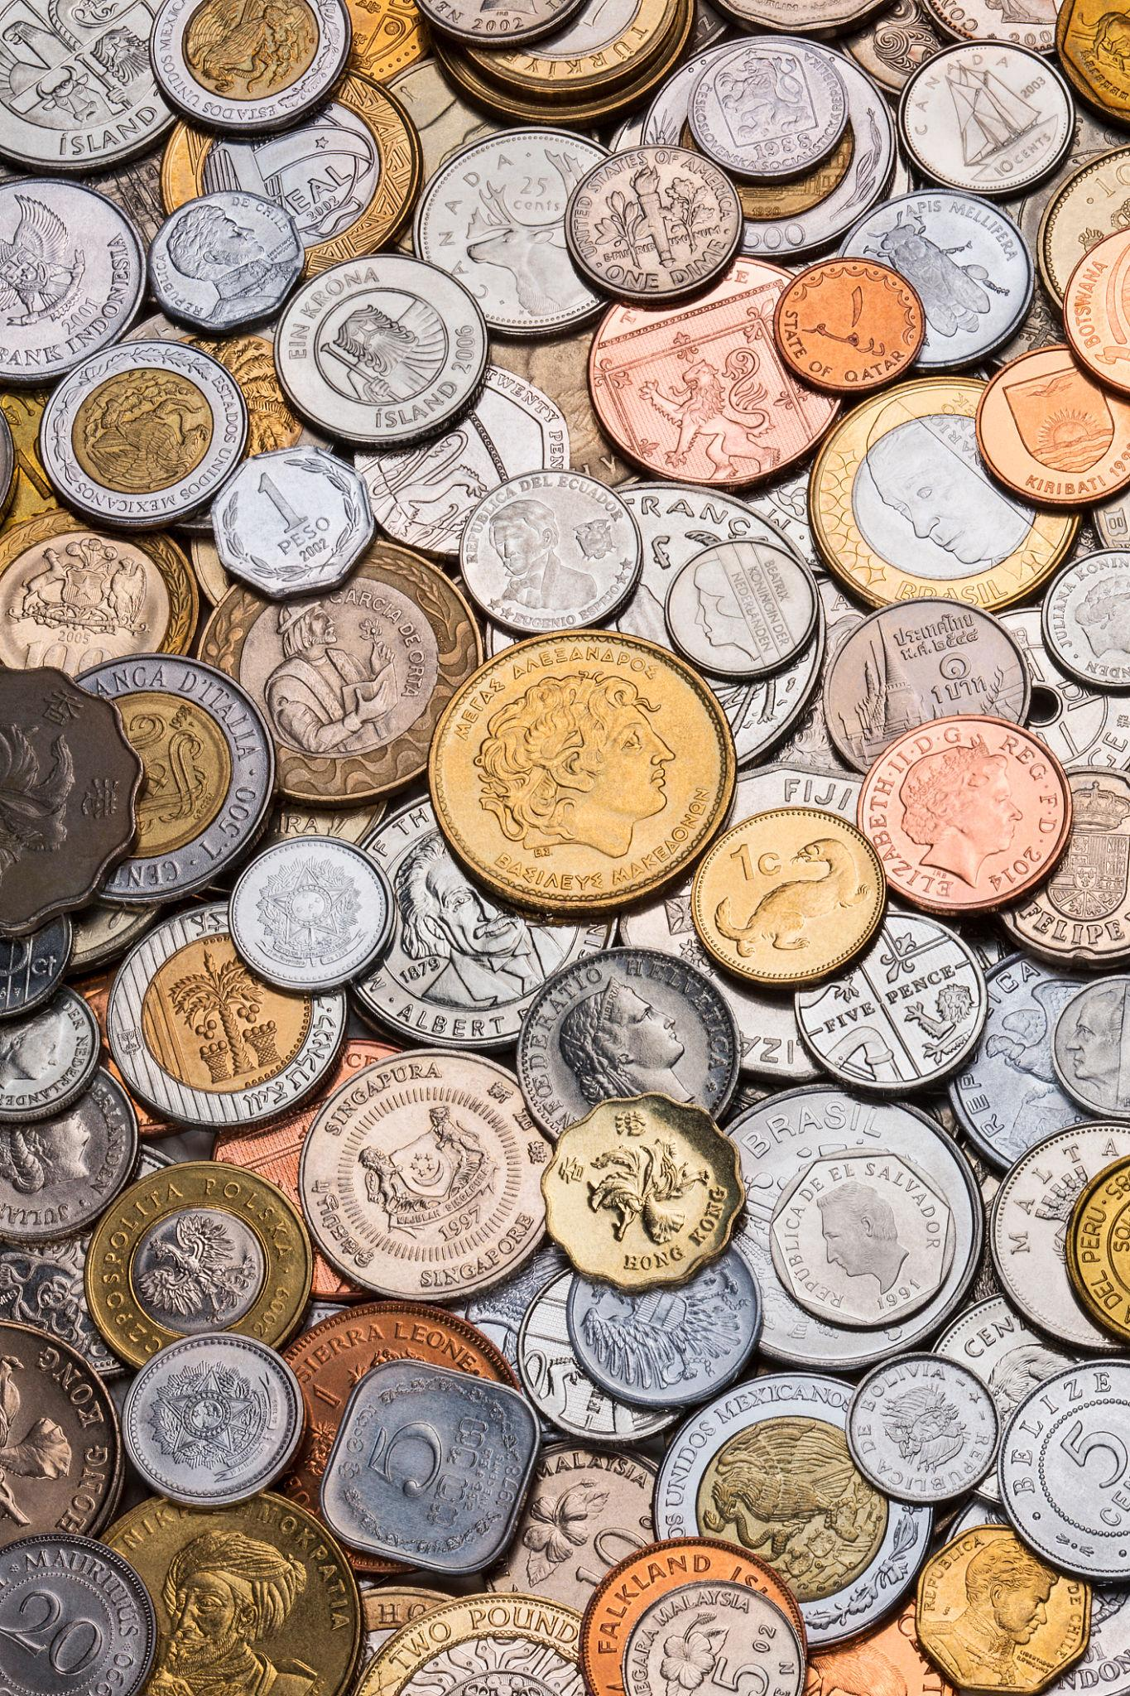
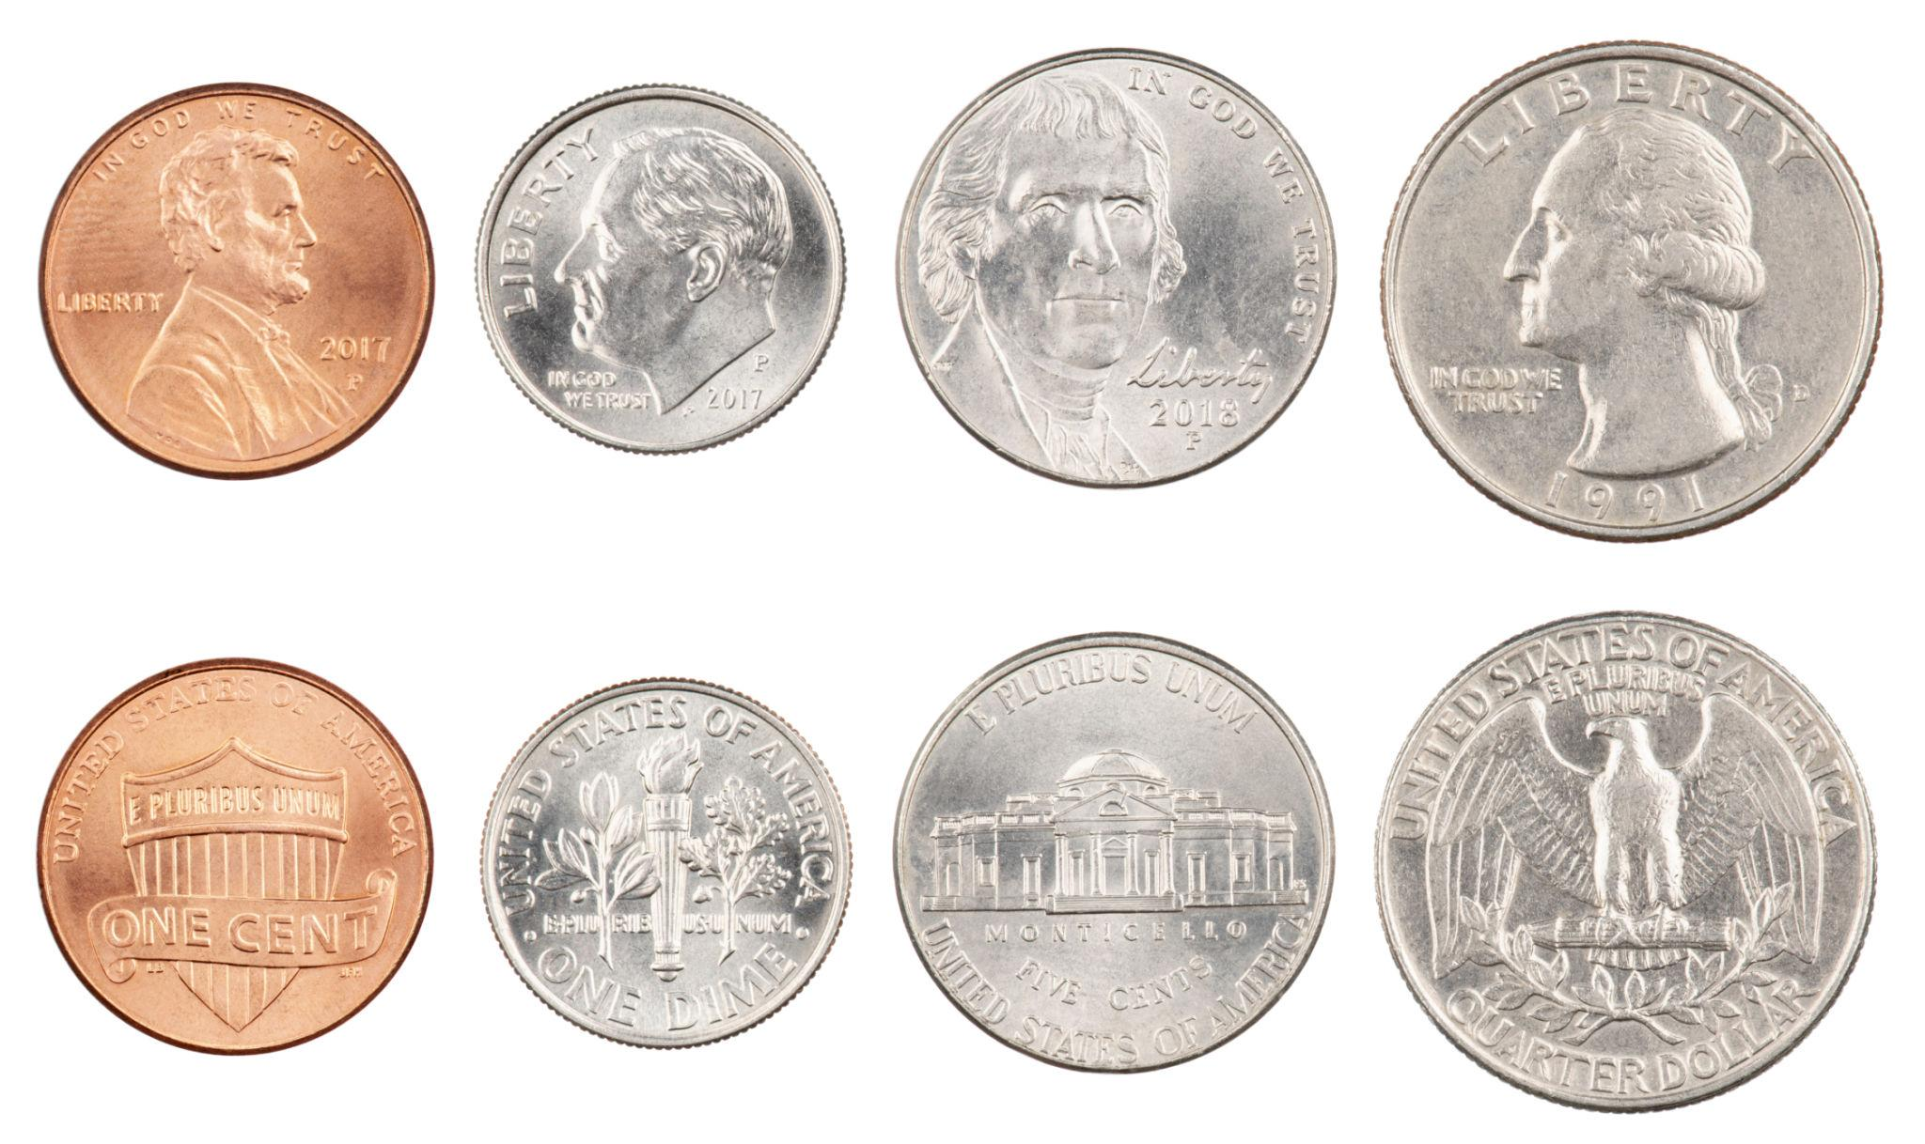
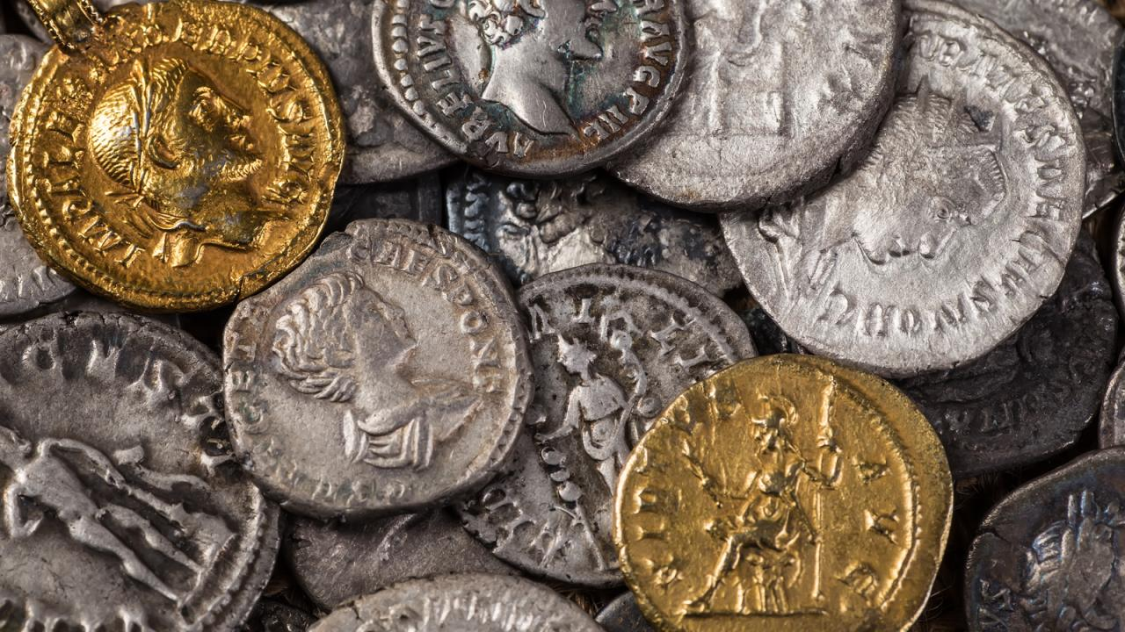
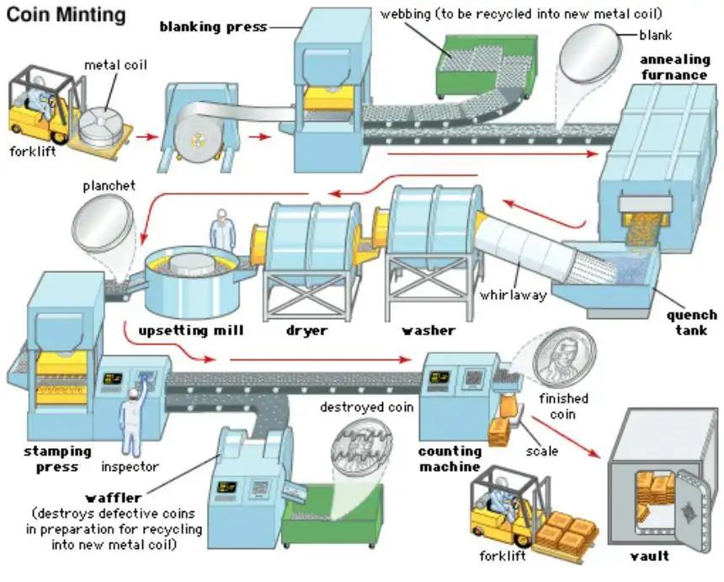
Coins are pieces of metal money issued by a government or central monetary authority. They are one of the oldest forms of money and are primarily used for small-value transactions. Each coin has an officially assigned value, known as its face value, which is guaranteed by the issuing authority.

Definition
# Source: AI Source: Provided by: [Data Path: Persons Table -> ID Column: 1, Name_En Column: Motasem Essam] -> From: [ChatGPT] on [7/17/2026]
A Coin is a standardized piece of metal issued by a government or monetary authority, used as legal tender for making payments and measuring monetary value.

Purpose
# Source: AI Source: Provided by: [Data Path: Persons Table -> ID Column: 1, Name_En Column: Motasem Essam] -> From: [ChatGPT] on [7/17/2026]
Coins are used to:
- Pay for low-cost goods and services.
- Provide change in cash transactions.
- Represent smaller units of a currency.
- Facilitate everyday purchases.

Characteristics of Coins
# Source: AI Source: Provided by: [Data Path: Persons Table -> ID Column: 1, Name_En Column: Motasem Essam] -> From: [ChatGPT] on [7/17/2026]
Coins typically have the following features:
- Made of durable metal or metal alloys.
- Circular in shape (most commonly).
- Stamped with a face value.
- Carry national symbols, historical figures, or important landmarks.
- Produced by an official mint.

Parts of a Coin
# Source: AI Source: Provided by: [Data Path: Persons Table -> ID Column: 1, Name_En Column: Motasem Essam] -> From: [ChatGPT] on [7/17/2026]
A coin generally includes:

Part | Description
Obverse | The front side, often showing a national leader, monarch, or emblem.
Reverse | The back side, usually displaying the denomination, national symbols, or commemorative designs.
Edge | The outer rim, which may be smooth, reeded (grooved), or inscribed to help prevent counterfeiting.

Materials Used
# Source: AI Source: Provided by: [Data Path: Persons Table -> ID Column: 1, Name_En Column: Motasem Essam] -> From: [ChatGPT] on [7/17/2026]
Modern coins are commonly made from:
- Copper
- Nickel
- Zinc
- Brass
- Bronze
- Steel
- Aluminum
- Bi-metallic combinations (two different metals)
Historically, valuable coins were made from:
- Gold
- Silver

Examples
# Source: AI Source: Provided by: [Data Path: Persons Table -> ID Column: 1, Name_En Column: Motasem Essam] -> From: [ChatGPT] on [7/17/2026]
Coins represent the minor units of a currency.
Examples:

Currency | Common Coins
US Dollar (USD) | 1¢, 5¢, 10¢, 25¢, 50¢, $1
Euro (EUR) | 1c, 2c, 5c, 10c, 20c, 50c, €1, €2
British Pound (GBP) | 1p, 2p, 5p, 10p, 20p, 50p, £1, £2
Egyptian Pound (EGP) | 25 piastres, 50 piastres, E£1

Legal Tender
# Source: AI Source: Provided by: [Data Path: Persons Table -> ID Column: 1, Name_En Column: Motasem Essam] -> From: [ChatGPT] on [7/17/2026]
Coins issued by a country's official monetary authority are considered legal tender, meaning they can legally be used to settle debts and make payments within that country.

Manufacturing
# Source: AI Source: Provided by: [Data Path: Persons Table -> ID Column: 1, Name_En Column: Motasem Essam] -> From: [ChatGPT] on [7/17/2026]
Coins are produced through a process called minting.
Typical steps include:
- Producing metal blanks.
- Heating and preparing the blanks.
- Stamping both sides with engraved dies.
- Inspecting and distributing the finished coins.
The facilities where coins are manufactured are called mints.

Advantages
# Source: AI Source: Provided by: [Data Path: Persons Table -> ID Column: 1, Name_En Column: Motasem Essam] -> From: [ChatGPT] on [7/17/2026]
Coins:
- Are durable and long-lasting.
- Resist water and wear.
- Are difficult to tear or damage.
- Suitable for frequent circulation.
- Useful for vending machines and public transportation.

Limitations
# Source: AI Source: Provided by: [Data Path: Persons Table -> ID Column: 1, Name_En Column: Motasem Essam] -> From: [ChatGPT] on [7/17/2026]
Coins:
- Are heavier than paper money.
- Can be inconvenient in large quantities.
- Usually represent lower monetary values.
- Cost more to produce than some digital transactions.

Applications
# Source: AI Source: Provided by: [Data Path: Persons Table -> ID Column: 1, Name_En Column: Motasem Essam] -> From: [ChatGPT] on [7/17/2026]
Coins are commonly used in:
- Retail purchases
- Public transportation
- Parking meters
- Vending machines
- Banks
- Collecting (numismatics)

Historical Importance
# Source: AI Source: Provided by: [Data Path: Persons Table -> ID Column: 1, Name_En Column: Motasem Essam] -> From: [ChatGPT] on [7/17/2026]
Coins were among the earliest standardized forms of money.
The first widely recognized metal coins were introduced in the ancient kingdom of Lydia (in present-day Türkiye) around the 7th century BCE, marking an important development in trade and economic history.

Common Mistakes
# Source: AI Source: Provided by: [Data Path: Persons Table -> ID Column: 1, Name_En Column: Motasem Essam] -> From: [ChatGPT] on [7/17/2026]
- Confusing a coin's face value with the value of its metal.
- Assuming all old coins are valuable (many have only face value).
- Thinking coins are no longer important because of digital payments—they remain widely used in many economies.

Interesting Facts
# Source: AI Source: Provided by: [Data Path: Persons Table -> ID Column: 1, Name_En Column: Motasem Essam] -> From: [ChatGPT] on [7/17/2026]
- The study and collection of coins is called numismatics.
- Some modern coins use two different metals (bi-metallic coins) to improve security and durability.
- Commemorative coins are often issued to celebrate important historical events, anniversaries, or notable people.

Key Points
# Source: AI Source: Provided by: [Data Path: Persons Table -> ID Column: 1, Name_En Column: Motasem Essam] -> From: [ChatGPT] on [7/17/2026]
- Coins are metal forms of money.
- They are issued by governments or central monetary authorities.
- Coins are mainly used for small-value transactions.
- Modern coins are made from durable metal alloys.
- Officially issued coins are legal tender.
- Coins have been used in commerce for over 2,600 years.

Conclusion
# Source: AI Source: Provided by: [Data Path: Persons Table -> ID Column: 1, Name_En Column: Motasem Essam] -> From: [ChatGPT] on [7/17/2026]
Coins are one of the oldest and most durable forms of money, serving as standardized metal currency for everyday transactions. Issued by governments and central monetary authorities, they provide a reliable means of making small payments, giving change, and representing the minor units of a currency. Despite the growth of digital payment systems, coins continue to play an essential role in modern economies because of their durability, convenience, and legal recognition.

